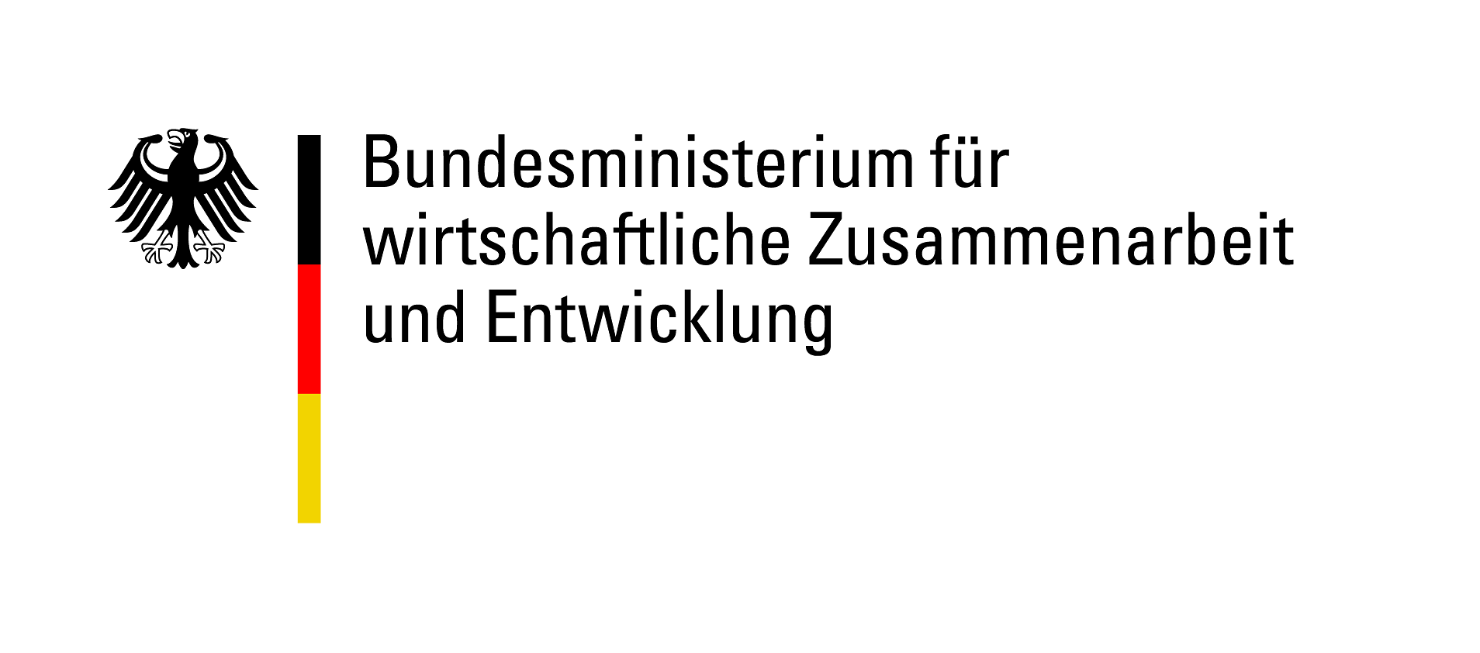



ENGAGEMENT GLOBAL gGmbH

Abt. Förderung Freiwilligenaustausch

Friedrich-Ebert-Allee 40

53113 Bonn

**PILOT PROJECT APPLICATION**

to ENGAGEMENT GLOBAL gGmbH

for a subsidy funded by the Federal Ministry for Economic Cooperation and Development (BMZ)

under the “**weltwärts Extracurricular exchange projects in the context of Agenda 2030”** funding guideline

# 1. Details of application partnership

|  |  |  |  |  |
| --- | --- | --- | --- | --- |
| **Organisation** | **Project partner in Germany** | | | **Project partner in partner country** |
| 1. Registration number | FEB:  or  weltwärts-Freiwilligendienst:       or  weltwärts Begegnung: | | |  |
| 2. Name of applicant organisation |  | | |  |
| 3. Address |  | | |  |
| 4. Address – additional information | , | , |  |  |
| 5. Telephone number | + | | | + |
| 6. Email address |  | | |  |
| 7. Website | www. | | | www. |
| 8. Account holder |  | | |  |
| 9. Bank account details | IBAN      , BIC | | |  |
| **Contact person(s) for project** |  | | |  |
| 10.Title, surname | , | | | , |
| 11. First name(s) |  | | |  |
| 12. Role |  | | |  |
| 13. Telephone number | + | | | + |
| 14. Email address |  | | |  |
| 15. Instant Messenger |  | | |  |
| 16. Fax | + | | | + |

# 2. Start of partnership and joint activities so far

|  |  |
| --- | --- |
| 1. Since when have the project partners been in contact?  (Please enclose the official declaration of partnership here if there is one) | Contact established specifically for this project  Since: Click here to enter a date |
| 2. If the partnership already exists, what joint activities have been implemented in the past two years? | 1. Title, from Klicken Sie hier, um ein Datum einzugeben. to Klicken Sie hier, um ein Datum einzugeben., country      , number of participants      , brief description  2. Title, from Klicken Sie hier, um ein Datum einzugeben. to Klicken Sie hier, um ein Datum einzugeben., country      , number of participants      , brief description  3. Title, from Klicken Sie hier, um ein Datum einzugeben. to Klicken Sie hier, um ein Datum einzugeben., country      , number of participants      , brief description |

# 3. Basic information on the pilot project

|  |  |
| --- | --- |
| 1. Title of pilot project |  |
| 2. Total duration | From Klicken Sie hier, um ein Datum einzugeben. to Klicken Sie hier, um ein Datum einzugeben. |
| 3. Type, duration and location of joint activities | Type,      , from to , location  Type,      , from to , location  Please add any additional dates as appropriate |
| 4. Brief description of planned pilot project (max. 500 characters) |  |
| 5. How will you ensure successful communication between the project participants? |  |
| 6. What form will the collaboration with the project partner(s) take in terms of content and organisation? |  |
| 7. How will you ensure that diversity aspects are taken into account in the project? |  |

# 4. Planned make-up of pilot project participants

|  |  |  |  |  |
| --- | --- | --- | --- | --- |
| **PROJECT STAFF (persons involved in designing, implementing and evaluating the project)** | | | | |
|  | **Number** | **Organisation(s)** | **Place, country** | **Role/duty** |
| Project staff  Germany, paid |  |  |  |  |
| Project staff  Germany voluntary |  |  |  |  |
| Project staff  Partner country/countries, paid |  |  |  |  |
| Project staff  Partner country/countries voluntary |  |  |  |  |
| Total |  |  |  |  |
| **TARGET GROUP(S) REACHED BY THE PILOT PROJECT** | | | | |
|  | **Number** | **Organisation(s)** | **Place, country** | **Role/duty** |
| **Germany** |  | | | |
| Adolescents/young adults |  |  |  |  |
| Disseminators, paid |  |  |  |  |
| Disseminators, voluntary |  |  |  |  |
| Other |  |  |  |  |
| Total |  |  |  |  |
| **Partner country/countries** |  | | | |
| Adolescents/young adults |  |  |  |  |
| Disseminators, paid |  |  |  |  |
| Disseminators, voluntary |  |  |  |  |
| Other |  |  |  |  |
| Total |  |  |  |  |
| GRAND TOTAL |  |  |  |  |

# 5. Objectives and achievement of objectives for the pilot project

|  |  |
| --- | --- |
| 1. Please describe the main objective of the pilot project. |  |
| 2. Which of the SDGs is the pilot project based on? | Wählen Sie ein Element aus. |
| 3. Please describe how the project will have a positive impact on international/development-related youth work. |  |
| 4. What criteria will you use to verify whether the objectives of the pilot project have been achieved? |  |

# 6. Objectives, methods and schedule for each phase of the pilot project

6.1 Please describe specific, measurable goals for each project phase you have defined (e.g. preparation, main activity, follow-up) and the methods that will be used to achieve the objectives, taking into account the funding principles (partnership, involvement, balance, evaluation, diversity, sustainability).

|  |
| --- |
|  |

6.2 Please enclose a schedule and seminar plan plus your overall plan for the content to be covered.

# 7. Innovation and transferability of the project

7.1 Please explain what makes the pilot project innovative. What new added value does it provide for international youth work?

|  |
| --- |
|  |

7.2 Please explain how the project is transferable:

- **How** will you ensure transferability?

- How can the project be transferred to other **target groups**?

- Which other **project partners** can apply the pilot project?

- What other situations and **contexts** can the pilot project be transferred to?

|  |
| --- |
|  |

# 8. Follow-up for pilot project/outlook

|  |  |
| --- | --- |
| 1. How will you evaluate/document whether the objectives have been achieved? |  |
| 2. How will results, methods and plans be documented and made accessible to the public? |  |
| 3. How will the project’s sustainability be ensured? |  |

# 9. Declarations

We declare our consent to this application being forwarded to the BMZ if necessary. We also consent to the BMZ disclosing in confidence to the German Bundestag’s Budget Committee the name of the applicant organisation and the amount and purpose of the grant in individual cases where the Budget Committee requests this information.

We hereby confirm that no other funding has been applied for or approved for the project for which this application is made.

We will make available any images and documentation produced in connection with the project to ENGAGEMENT GLOBAL and hereby grant the latter non-exclusive right of use, unrestricted in terms of place, content and time. We agree to support ENGAGEMENT GLOBAL by providing images and documentation produced in connection with the project. We give our consent to the details of our organisation being published on the ENGAGEMENT GLOBAL website and the website of the funding programme in question.

We undertake to grant the BMZ or persons authorised to conduct audits unrestricted access to documents (financial accounts, project reports, etc.) for the purpose of assessment/inspection and – if required – to allow them to visit projects.

The project will not result in any subsequent expenses that cannot be covered by our own funds.

We hereby confirm that the planned project cannot be carried out without funding from ENGAGEMENT GLOBAL/BMZ.

Please place a cross next to the relevant statement below:

The German project partner is entitled to deduct input tax.

The German project partner is entitled to deduct input tax to a limited degree.

The German project partner is not entitled to deduct input tax.

We confirm that the project for which the grant has been applied for has not yet started.

The application partners give their consent to the data provided with regard to the applicant organisations (not including private addresses) being passed on for the purpose of supporting networking activities and provision of information on training and partner searches.

I consent I do not consent

|  |  |
| --- | --- |
|  |  |
| Place and date of signature; legally binding signature of authorised signatory or person authorised by law/by applicant organisation’s regulations to act as a representative | Place and date of signature; signature of project partner’s authorised signatory |

# 10. Annex 1 Binding cost budget and financing plan

Please complete and print off the Excel spreadsheet and submit it with your application.

# 11. Annex 2 Further additional partners (if any)

Please use the template "additional partners" for this purpose.