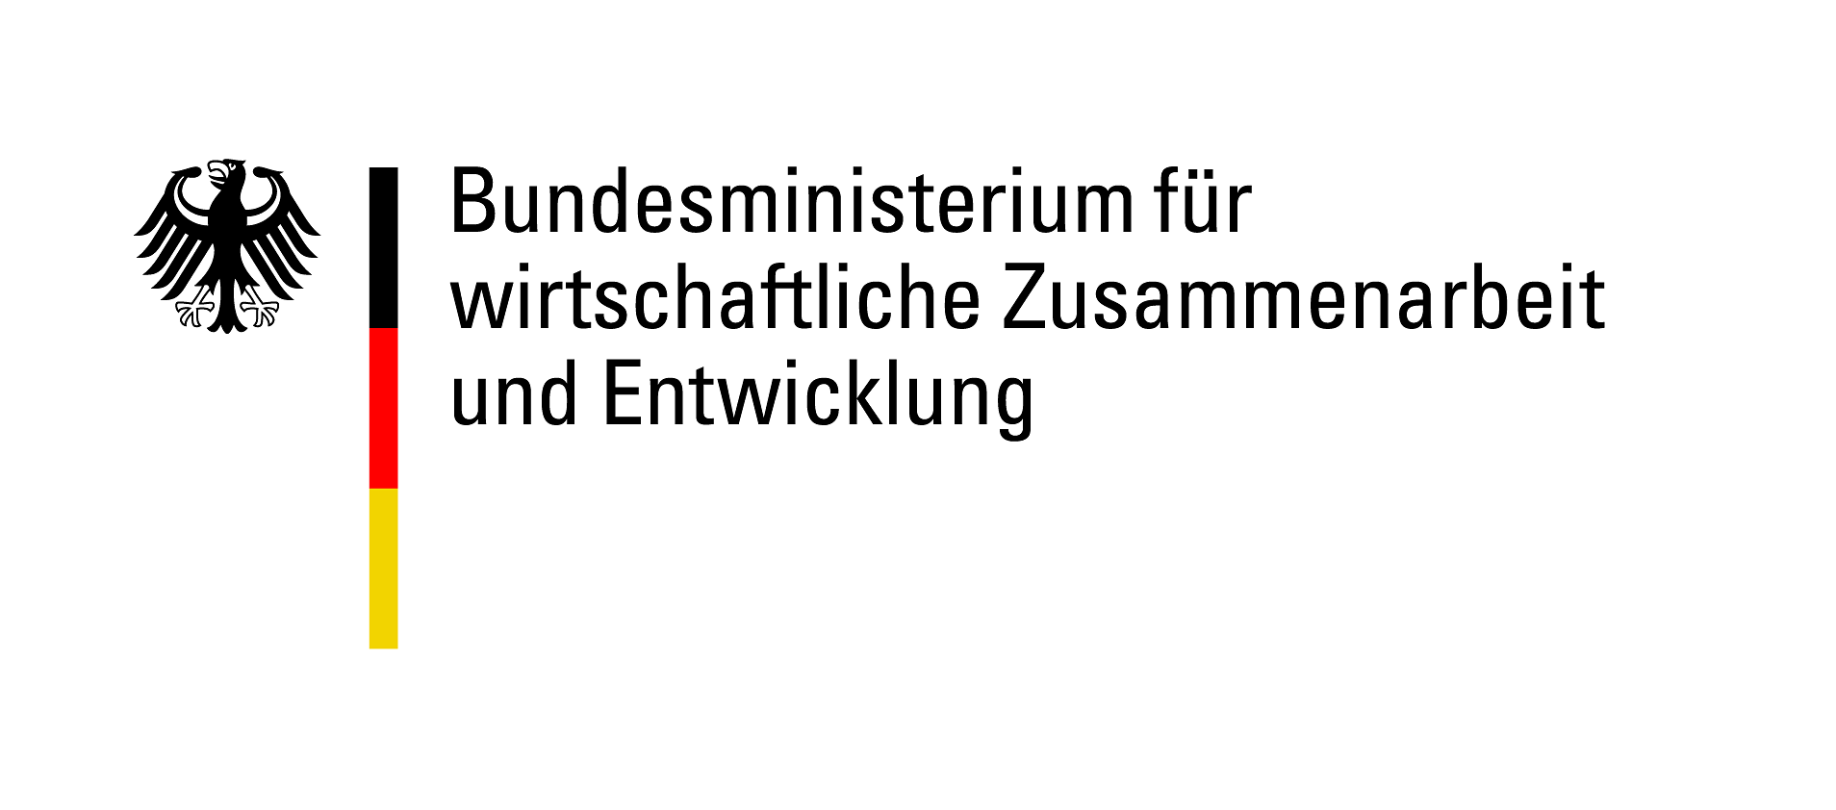


ENGAGEMENT GLOBAL gGmbH
Abt. Förderung Freiwilligenaustausch
Friedrich-Ebert-Allee 40
53113 Bonn

ACCOMPANYING PROJECT APPLICATION
to ENGAGEMENT GLOBAL gGmbH
for a subsidy funded by the Federal Ministry for Economic Cooperation and Development (BMZ)
under the “weltwärts Extracurricular exchange projects in the context of Agenda 2030” funding guideline

Details of application partnership
Organisation | Project partner in Germany |  |  | Project partner in partner country
1.Engagement Global registration number (if there is one)
2.Name of applicant organisation
3.Address
4.Address – additional information | , | ,
5. Telephone number | + |  |  | +
6. Email address
7. Website | www. |  |  | www.
Contact person(s) for project
10.Title, surname | , |  |  | ,
11. First name(s)
12. Role
13. Telephone number | + |  |  | +
14. Email address
15. Instant Messenger
16. Fax | + |  |  | +

Start of partnership and joint activities so far
1. Since when have the project partners been in contact?  (Please enclose the official declaration of partnership here if there is one) | ☐ Contact established specifically for this project  ☐ Since: Click here to enter a date
2. If the partnership already exists, what joint activities have been implemented in the past two years? | 1. Title, from Klicken Sie hier, um ein Datum einzugeben. to Klicken Sie hier, um ein Datum einzugeben., country , number of participants , brief description  2. Title, from Klicken Sie hier, um ein Datum einzugeben. to Klicken Sie hier, um ein Datum einzugeben., country , number of participants , brief description  3. Title, from Klicken Sie hier, um ein Datum einzugeben. to Klicken Sie hier, um ein Datum einzugeben., country , number of participants , brief description

3. Basic information on the accompanying project
1. Title of accompanying project
2. Total duration | From Klicken Sie hier, um ein Datum einzugeben. to Klicken Sie hier, um ein Datum einzugeben.
3. Type, duration and location of joint activities | Type , from____ to____, location  Type , from____ to____, location  Please add any additional dates as appropriate
4. Brief description of planned accompanying project (max. 500 characters)
5. What measures to you intend to take to ensure successful communication between the participants from the participating countries?
6. What form will the collaboration with the project partner take in terms of content and organisation?
7. How will diversity be ensured in the group and how will participants’ different needs be catered for in the programme?

4. Planned make-up of participants’ group of youth workers/staff

 | Number | Organisations | Location | Role/duty, if known
Youth workers/staff from Germany, voluntary
Youth workers/staff from Germany, paid
Youth workers/staff from partner country, voluntary
Youth workers/staff from partner country, paid
Total

5. Objectives and achievement of objectives for the accompanying project
1. Please choose the main objective of the accompanying project. | Wählen Sie ein Element aus.
2. Please describe how this objective helps increase the number or improve the quality of youth exchange projects.
3. Which SDG do the youth exchange projects resulting from the accompanying project pursue? | Wählen Sie ein Element aus.
4. What criteria will you use to verify whether the objectives of the accompanying project have been achieved?

6. Objectives, methods and schedule for each project phase

6.1 Please define specific, measurable goals for each project phase (preparation, main activities/visit, follow-up) and the methods that will be used to achieve the objectives, taking into account the funding principles (partnership, involvement, balance, evaluation, diversity, sustainability).
6.2 Please enclose a schedule and seminar plan for each project phase.

7. Follow-up for accompanying project/outlook
1. How will you evaluate/document whether the objectives have been achieved?
2. How will the participants be given motivation and connected with one another so that they can continue their civic engagement?
3. How will the sustainability of the project be ensured?
4. Please describe any projects that will arise as a direct result of the accompanying project.

8. Declarations
We declare our consent to this application being forwarded to the BMZ if necessary. We also consent to the BMZ disclosing in confidence to the German Bundestag’s Budget Committee the name of the applicant organisation and the amount and purpose of the grant in individual cases where the Budget Committee requests this information.
We hereby confirm that no other funding has been applied for or approved for the project for which this application is made.
We will make available any images and documentation produced in connection with the project to ENGAGEMENT GLOBAL and hereby grant the latter non-exclusive right of use, unrestricted in terms of place, content and time. We agree to support ENGAGEMENT GLOBAL by providing images and documentation produced in connection with the project. We give our consent to the details of our organisation being published on the ENGAGEMENT GLOBAL website and the website of the funding programme in question.
We undertake to grant the BMZ or persons authorised to conduct audits unrestricted access to documents (financial accounts, project reports, etc.) for the purpose of assessment/inspection and – if required – to allow them to visit projects.
The project will not result in any subsequent expenses that cannot be covered by our own funds.
We hereby confirm that the planned project cannot be carried out without funding from ENGAGEMENT GLOBAL/BMZ.
Please place a cross next to the relevant statement below:
☐ The German project partner is entitled to deduct input tax.
☐ The German project partner is entitled to deduct input tax to a limited degree.
☐ The German project partner is not entitled to deduct input tax.
We confirm that the project for which the grant has been applied for has not yet started.
The application partners give their consent to the data provided with regard to the applicant organisations (not including private addresses) being passed on for the purpose of supporting networking activities and provision of information on training and partner searches.
☐I consent ☐I do not consent

Place and date of signature; legally binding signature of authorised signatory or person authorised by law/by applicant organisation’s regulations to act as a representative | Place and date of signature; signature of project partner’s authorised signatory

9. Annex 1 Binding cost budget and financing plan
Please complete and print off the Excel spreadsheet and submit it with your application.

10. Annex 2 Further cooperation partners (if any)
Please use the template "Cooperation partner" for this purpose.

