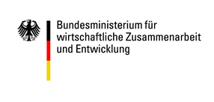

Annex: Details of cooperation partners

 | Cooperation partner from Germany | Cooperation partner from partner country
In which functions are other  project partners involved? | ☐ The project will use “piggybacking” procedure: there is a cooperation agreement between the applicant organisation that fulfils the legal requirements and the partner named below, whereby the former provides support to the latter and submits the application on its behalf  ☐ The project will be conducted with the involvement of the relevant umbrella association/consortium/interest group. | ☐ The project will use “piggybacking”: there is a cooperation agreement between the applicant organisation from the partner country and the partner named below, whereby the former provides support to the latter.  ☐ The project will be multilateral and involve another project partner.
Please give a brief description of the tasks to be performed by the partner organisation on the project or enclose a copy of the cooperation agreement.

 | Cooperation partner in Germany | Cooperation partner in partner country
1. Engagement Global registration number (if there is one)
2.Name of organisation
3.Full address
4. Location, Country Code, Country | , Germany
5. Telephone number | + | +
6. Email address
7. Website | www. | www.
Contact person(s)
8.Title, surname | , | ,
9. First name(s)
10. Role
11. Telephone number | + | +
12. Email address
13. Instant Messenger
14. Fax | + | +

